

ECONOMICS

Practice SAC 2.1.2.1 – Budgetary and Monetary Policy

UNIT 2 - OUTCOME 2

You will have 80 minutes to complete this task.

The SAC is a Structured Questions Test

The total SAC is worth 10% of your Unit 1 grade.

Conditions and restrictions
- Students are permitted to bring into the room for this task: pens, pencils, highlighters, erasers, sharpeners and rulers
- Students are NOT permitted to bring into the room for this task: blank sheets of paper and/or white out liquid/tape.

Materials supplied
- Question and answer book of 12 pages

Instructions
- Print your name in the space provided on the top of the front page.
- All written responses must be in English.

Student name ____________________________________________

Grade/Score: ____/___30 Satisfactory Completion? S/N: ______
(Provisional)
--------------------------------------------------------------------------------------
Assessment Criteria
This assessment task was developed using the Outcome 1 key knowledge and skills in Unit 2 VCE Economics:
Key knowledge

• government economic policy responses designed to influence the rate of economic growth: budgetary policy and monetary policy

Key skills
• define key economic concepts and terms and use them appropriately
• access and synthesise information gathered from a range of sources and draw conclusions
• identify trends, patterns, similarities and differences in economic data and other information
• gather, interpret and analyse statistical and graphical data
• evaluate the potential costs and benefits associated with economic activity.

SECTION A – Multiple Choice
Instructions for Section A
Answer all questions.
Choose the response that is correct or that best answers the question.
A correct answer scores 1, an incorrect answer scores 0.
A mark will not be awarded if more than one response is chosen for a question.

Question 1
A tightening of monetary policy in Australia is most likely to occur if the

A. rate of inflation moves above the Reserve Bank of Australia’s target range
B. unemployment rate significantly increases
C. exchange rate suddenly appreciates
D. size of the budget surplus increases

Question 2
The Reserve Bank of Australia’s current medium term monetary policy objective is

A. to minimise the rate of inflation
B. to maximise the rate of economic growth
C. to keep the inflation rate between 0 and 3 percent over the business cycle
D. to keep the annual inflation rate between 2 and 3 per cent on average over the business cycle

Question 3
Which one of the following is an example of a discretionary budget policy?
A. a decrease in the cash interest rate
B. a decrease in the company tax rate from 30 per cent to 29 per cent
C. an increase in welfare payments due to a rise in cyclical unemployment
D. lower revenue from a minerals resource rent tax (MRRT) due to falling commodity prices

Question 4
Consider the following GDP and unemployment rate data for a hypothetical economy over a two-year period.

Year | GDP  (%) | Unemployment  (%)
1 | 3.1 | 4.9
2 | 1.8 | 5.2

With reference to the data in the table above, at the end of Year 2, what is the likely response of Monetary and Budgetary Policy?

A. expansionary budgetary policy and expansionary monetary policy
B. contractionay budgetary policy and contractionary monetary policy
C. expansionary budgetary policy and contractionary monetary policy
D. contractionary budgetary policy and expansionary monetary policy

Question 5
GDP growth above 3.5% would have which of the following effects on Budgetary Policy?

A. Expansionary budgetary policy stance and a worsening underlying budget outcome
B. Contractionary budgetary policy stance and an improving underlying budget outcome
C. Expansionary budgetary policy stance and an improving underlying budget outcome
D. Contractionary budgetary policy stance a worsening underlying budget outcome

SECTION B – Written responses
Instructions for Section B
Answer all questions in the spaces provided.

Question 1 (8 marks)
Refer to the 2019/20 Budget Overview (extract) and answer the following questions:
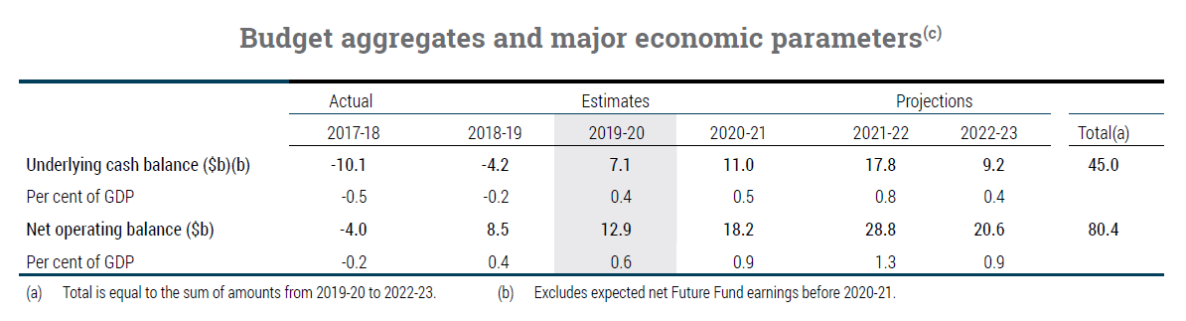
a. Comparing the underlying cash balance estimates in 2019–2020 with actual budget outcome for 2018–2019, describe the change in the stance of budgetary policy over the last two years.
(2 marks)

b. Explain how the Australian Government could utilise one discretionary initiative as part of the 2018-19 and one discretionary initiative 2019-20 Budget to achieve:

- real GDP growth
- Employment opportunities
(6 marks)

c. Assume that Australia entered a recession. Explain what is likely to happen to:
- Discretionary spending
- Underlying budget outcome
2 marks

Question 2 (4 marks)
a. Define monetary policy.
2 marks

b. Outline the role of the RBA with respect to monetary policy as outlined in its charter.
2 marks

Question 3 (11 marks)
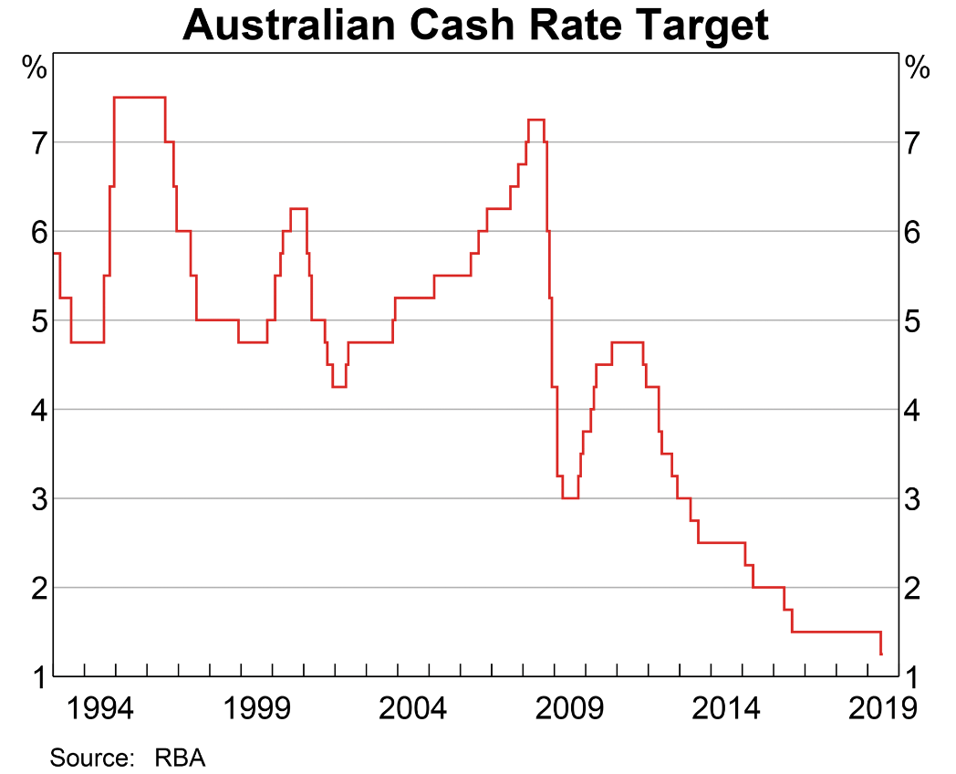
At its meeting today, the Board decided to lower the cash rate by 25 basis points to 1.00 per cent. This follows a similar reduction at the Board's June meeting. This easing of monetary policy will support employment growth and provide greater confidence that inflation will be consistent with the medium-term target.
Source: Philip Lowe, RBA governor, July monetary policy meeting

a. Using the chart above, describe the change in monetary policy stance since January 2017.

2 marks

b. Explain the focus of monetary policy setting over the past two years as a result of changes in unemployment, GDP growth and inflation.
3 marks

The Reserve Bank is responsible for Australia's monetary policy. Monetary policy involves setting the interest rate on overnight loans in the money market (‘the cash rate’). The cash rate influences other interest rates in the economy, affecting the behaviour of borrowers and lenders, economic activity and ultimately the rate of inflation.
Source: https://www.rba.gov.au/monetary-policy/

c. Explain how the Reserve Bank of Australia’s current monetary policy stance is likely to influence Aggregate Demand and the impact this may have on increasing real GDP growth and employment opportunities.
6 marks

Extra writing space
(clearly label all responses)

